**Dear Potential Donor,**

We hope this letter finds you well. As a valued Lakeville Community supporter, and in commemorative honor of Maxwell Wilson, we are reaching out in request of your sponsorship.

Tragically on June 3rd, Max was hit by a car while on his scooter trying to cross a busy road in Lakeville, Minnesota causing serious head trauma. Two days later on June 5th, Max succumbed to his injuries. Before passing Max was able to save 4 lives by generously donating 4 of his major organs. Max loved life, he was kind, hardworking and always included everyone. He lit up every room he entered with his infectious smile and welcoming personality.

We are announcing our upcoming memorial golf event, which includes a silent auction. The funds raised during this event will directly contribute to memorial projects, such as sports scholarships, and a yearly donation to the Lakeville North Youth Football Association. Your support will make a significant impact in the community. To make our event a success, we are seeking generous donations from individuals and businesses like yours.

**How You Can Help:**

Silent Auction Donation: We kindly request your support by donating an item or service to our silent auction. Your contribution will not only benefit our cause but also provide valuable exposure for your business. In return, we will recognize your generosity through event promotions, social media shout-outs, and signage during the auction.

Golf Hole Sponsorship: Additionally, we invite you to sponsor a golf hole or challenge during our tournament. By doing so, you’ll gain visibility among our participants and attendees, and we’ll acknowledge your support during the awards ceremony.

**Next Steps:**

Please let us know your preferred level of involvement by completing the form attached to this letter. Please send the completed form via email to [contact info] or mailed to [mailing address] and we will reach out to you directly with the details for your level of support.

Thank you for considering our request. Your partnership would be mutually beneficial, and we look forward to working together to create a memorable event that will create a significant impact on our community and honor of our beloved Maxwell Wilson.

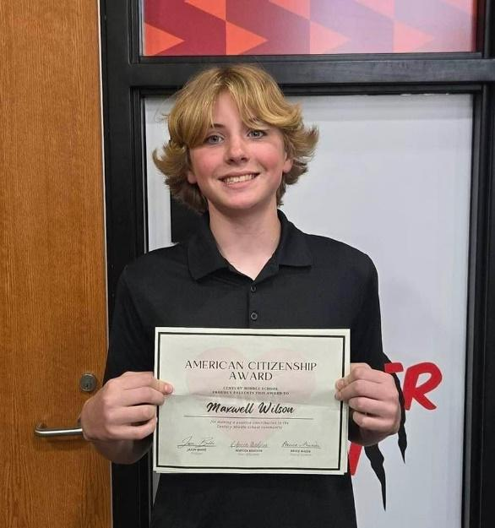

Warm regards,

Jenna Weber and Trina Wilson (Aunts)

[maxwilsonmemorialfund@gmail.com](mailto:maxwilsonmemorialfund@gmail.com)

Call or Text:

612-702-9910 (Jenna) or 507-838-0313(Trina)

**1st Annual Max Wilson Memorial Golf Tournament**

**Sponsorship Opportunities 2024**

**Date: Friday, August 23rd**

**Time: 9:00am shot gun start**

**Location: Crystal Lake Golf Course**

**Please Choose Your Sponsorship Level:**

* Silent Auction Item(s). Please Specify Items and Value: ______________________________________________________________________________
* $1000 Active Hole Sponsor (16 available) (host fun games, bring your signage, hand out company premiums, bring chairs/tables/tent as desired)

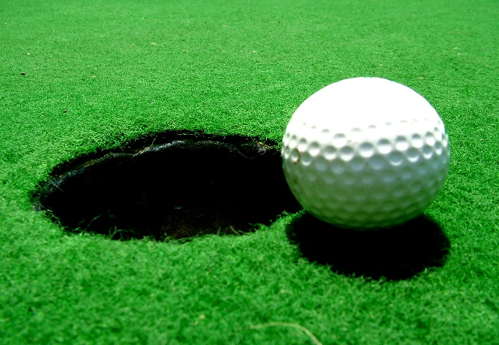

* Women’s Longest Putt
* Women’s Longest Drive
* Men’s Longest Putt
* Men’s Longest Drive
* Women’s Closest to Pin
* Men’s Closest to Pin
* First Place Team
* Second Place Team
* Third Place Team
* 24th Place Team (Max’s Football number)

Sponsor/ Organization Name: ___________________________________________

Email: ______________________________________________________________

Phone Number: ______________________________________________________

Please send this completed form to:

Jenna Weber or Trina Wilson

[maxwilsonmemorialfund@gmail.com](mailto:maxwilsonmemorialfund@gmail.com)

**For more information and questions please contact Jenna or Trina via text or email**

**Thank you for showing your support in honor of Max Wilson!**